Supplementary Materials

Table S1. Pathological staging before and after surgery in the NIAC group after matching (see Figure S2)
Pathological  staging | Clinical staging |  |  |  | Total
Pathological  staging | T1 | T2 | T3 | T4 | Total
T1 | 17 | 9 | 0 | 0 | 26
T2 | 0 | 21 | 4 | 0 | 25
T3 | 0 | 2 | 12 | 0 | 14
T4 | 0 | 0 | 7 | 6 | 13
Total | 17 | 32 | 23 | 6 | 78
Wilcoxon signed ranks test, Z=-0.645, P=0.519

Table S2. Pathological staging before and after surgery in the IAC group (see Figure S3)
Pathological  staging | Clinical staging |  |  |  |  |  | Total
Pathological  staging | T1 | T2a | T2b | T3a | T3b | T4a | Total
T1 | 1 | 4 | 1 | 1 | 2 | 0 | 9
T2a | 0 | 2 | 1 | 1 | 1 | 0 | 5
T2b | 0 | 0 | 1 | 0 | 1 | 0 | 2
T3a | 0 | 0 | 1 | 2 | 2 | 1 | 6
T3b | 0 | 0 | 0 | 0 | 1 | 2 | 3
T4a | 0 | 0 | 0 | 1 | 0 | 0 | 1
Total | 1 | 6 | 4 | 5 | 7 | 3 | 26
Wilcoxon signed ranks test, Z=-3.157, P=0.002

Table S3. Multivariable Cox proportional hazards model to estimate survival outcomes in the IAC and NIAC groups
Variables | Intra-arterial |  | No intra-arterial
Variables | p value | RR(95%CI) | p value | RR(95%CI)
BMI | --- | --- | 0.015 | 0.802(0.671-0.958)
Diabetes | 0.029 | 14.649(1.311-163.682) | --- | ---
Positive lymph nodes | --- | --- | 0.000 | 7.474(2.467-22.642)
Smoking history | --- | --- | 0.043 | 3.388(1.040-11.038)

Table S4. OS of the diabetes groupings in the IAC group (see Figure S4A)
 | Mean ST (mo) | Medium ST (mo) | 1-year CSR (95%CI) | 5-year CSR (95%CI) | 10-year CSR (95%CI)
No | 116.26 | --- | 0.947(0.681-0.992) | 0.947(0.681-0.992) | 0.947(0.681-0.992)
Yes | 57.75 | 11.00 | 0.500(0.057-0.846) | 0.500(0.057-0.846) | ---
ST: survival time; CSR: cumulative survival rate; OS: overall survival

Table S5. OS of the BMI groupings in the NIAC group (see Figure S4B)
 | Mean ST (mo) | Medium ST (mo) | 1-year CSR (95%CI) | 5-year CSR (95%CI) | 10-year CSR (95%CI)
＜25 | 101.28 | 135.00 | 0.896(0.768-0.955) | 0.761(0.608-0.861) | 0.685(0.508-0.809)
≥25 | 128.55 | --- | 1.000(0.000-1.000) | 0.917(0.000-1.000) | 0.917(0.000-1.000)
ST: survival time; CSR: cumulative survival rate; OS: overall survival; BMI: body mass index

Table S6. OS of the PLN groupings in the NIAC group (see Figure S4B)
 | Mean ST (mo) | Medium ST (mo) | 1-year CSR (95%CI) | 5-year CSR (95%CI) | 10-year CSR (95%CI)
No | 123.05 | 135.00 | 0.967(0.873-0.992) | 0.913(0.802-0.963) | 0.879(0.740-0.946)
Yes | 67.43 | 49.00 | 0.833(0.000-1.000) | 0.481(0.004-0.910) | 0.361(0.007-0.809)
ST: survival time; CSR: cumulative survival rate; CSS: cancer-specific survival; PLN: positive lymph nodes

Table S7. CSS of the PLN groupings in the NIAC group (see Figure S4B)
 | Mean ST (mo) | Medium ST (mo) | 1-year CSR (95%CI) | 5-year CSR (95%CI) | 10-year CSR (95%CI)
No | 125.09 | 135.00 | 0.983(0.886-0.998) | 0.928(0.819-0.973) | 0.894(0.752-0.957)
Yes | 91.82 | --- | 0.871(0.000-1.000) | 0.586(0.000-0.967) | 0.586(0.000-0.967)
ST: survival time; CSR: cumulative survival rate; CSS: cancer-specific survival; PLN: positive lymph nodes

Figure S1. Propensity-score matching analysis based on the length of follow-up (box plot)

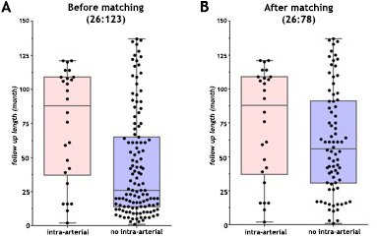

Figure S2. Changes in tumour staging in the NIAC group after matching (see Table S1).
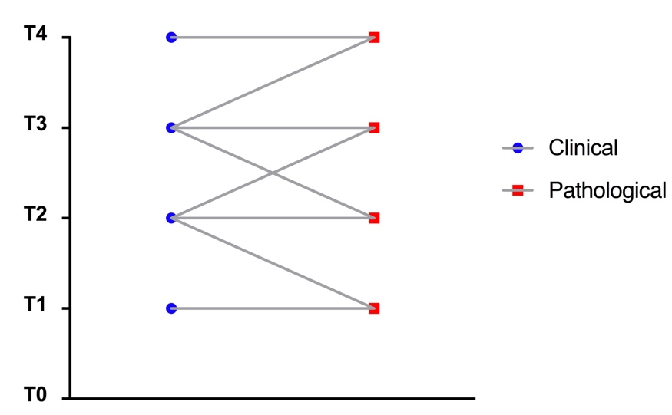

Figure S3. Changes in tumour staging in the IAC group (see Table S2).

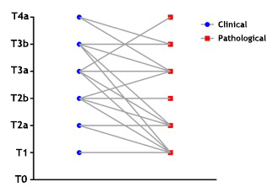

Figure S4. Overall survival and cancer-specific survival from Cox proportional hazards regression analysis (see Tables S4-S7).
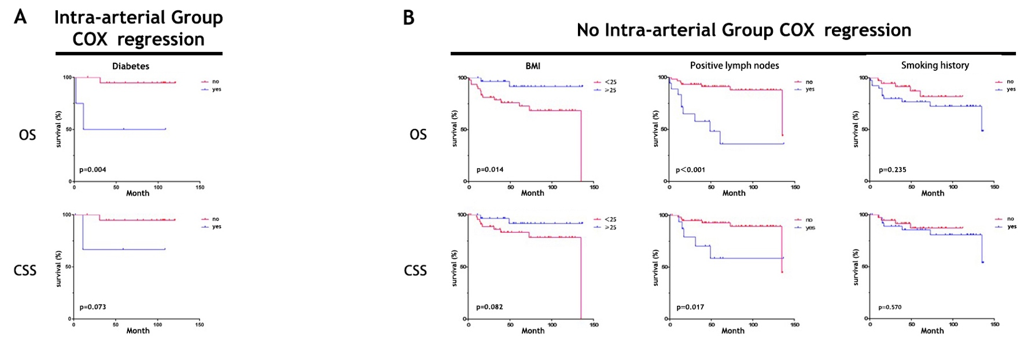
A summary of the published neoadjuvant IAC papers, including key information on the chemotherapy regimens, is provided in Table 6.
Search strategy
Search strings were used to interrogate the following databases: Medline, Embase and the Cochrane Library. Potential articles were identified using the National Library of Medicine’s Medical Subject Headings: “(((((((((((((((((((((Neoplasm, Urinary Bladder[Title/Abstract]) OR Urinary Bladder Neoplasm[Title/Abstract]) OR Neoplasms, Bladder[Title/Abstract]) OR Bladder Neoplasms[Title/Abstract]) OR Bladder Neoplasm[Title/Abstract]) OR Neoplasm, Bladder[Title/Abstract]) OR Bladder Tumors[Title/Abstract]) OR Bladder Tumor[Title/Abstract]) OR Tumor, Bladder[Title/Abstract]) OR Tumors, Bladder[Title/Abstract]) OR Urinary Bladder Cancer[Title/Abstract]) OR Cancer, Urinary Bladder[Title/Abstract]) OR Malignant Tumor of Urinary Bladder[Title/Abstract]) OR Cancer of the Bladder[Title/Abstract]) OR Bladder Cancer[Title/Abstract]) OR Bladder Cancers[Title/Abstract]) OR Cancer, Bladder[Title/Abstract]) OR Cancer of Bladder[Title/Abstract])) OR "Urinary Bladder Neoplasms"[Mesh])) AND (((((((((((((((((((((Infusion, Intra-Arterial[Title/Abstract]) OR Intra-Arterial Infusion[Title/Abstract]) OR Intra-Arterial Infusions[Title/Abstract]) OR Infusions, Intraarterial[Title/Abstract]) OR Infusion, Intraarterial[Title/Abstract]) OR Intraarterial Infusion[Title/Abstract]) OR Intraarterial Infusions[Title/Abstract]) OR Infusions, Intra Arterial[Title/Abstract]) OR Arterial Infusion, Intra[Title/Abstract]) OR Arterial Infusions, Intra[Title/Abstract]) OR Infusion, Intra Arterial[Title/Abstract]) OR Intra Arterial Infusion[Title/Abstract]) OR Intra Arterial Infusions[Title/Abstract]) OR Infusions, Regional Arterial[Title/Abstract]) OR Arterial Infusion, Regional[Title/Abstract]) OR Arterial Infusions, Regional[Title/Abstract]) OR Infusion, Regional Arterial[Title/Abstract]) OR Regional Arterial Infusion[Title/Abstract]) OR Regional Arterial Infusions[Title/Abstract])) OR "Infusions, Intra-Arterial"[Mesh])” The search was finalized on March 21, 2019.

Selection of relevant articles
The selection of relevant articles was conducted in two steps. As a first step, one reviewer (S.L.) excluded clearly irrelevant studies or studies not meeting the eligibility criteria based on the title and abstract. Two reviewers (S.L. and W.W.) performed the final selection based on a review of the full text of the manuscripts (Fig. S5).

Figure S5. Flow diagram of the article selection process
